Year 4 Home Learning
Learning Log tasks – The Vikings
Choose one task to complete each week.
Record your learning in your homework learning log book. We will share your learning every Friday so be prepared to talk about what you have done!
Have fun!
Create a poster about a Viking god or goddess.  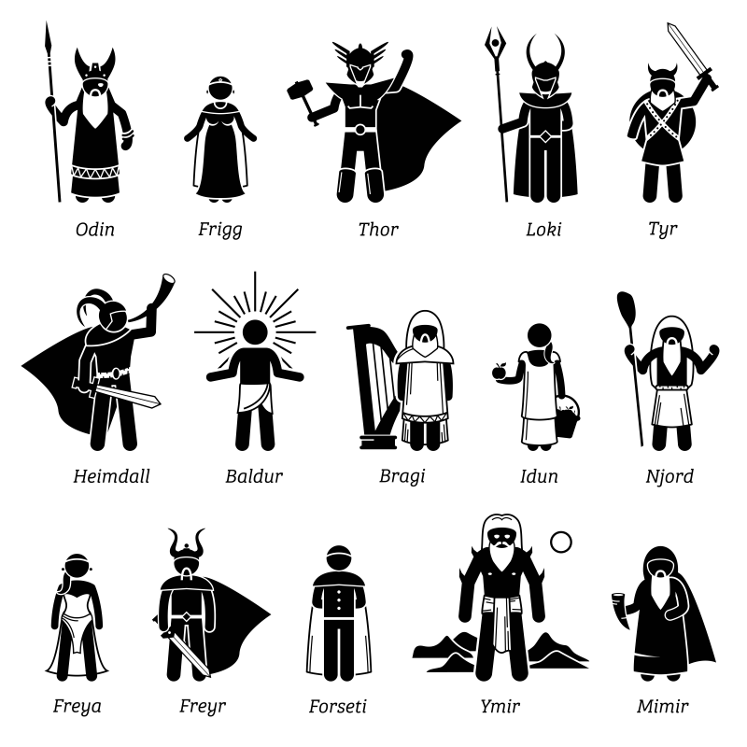 |  | Write your name in Viking runes. Can you write a secret message?  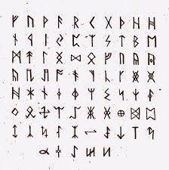
Create a map of Britain showing the Anglo-Saxon kingdoms and how they changed when the Vikings invaded. | Electricity Hunt: draw a plan of your house in your book and label it with where in the home you have electricity.  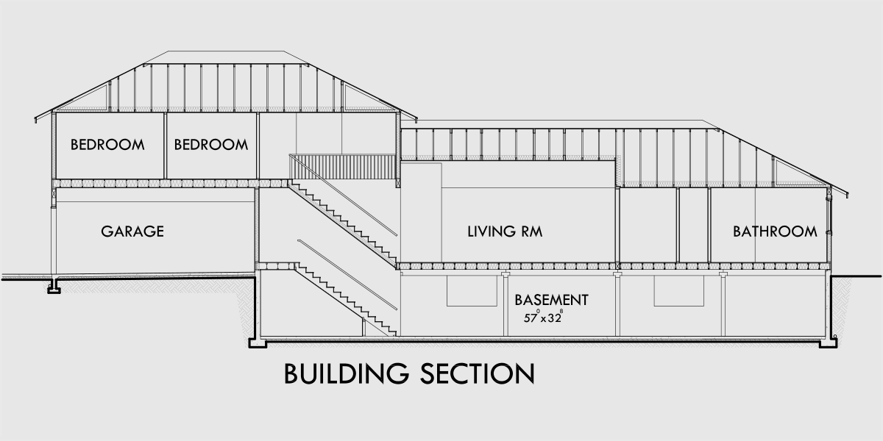
Draw or paint a picture of a Viking god, goddess or warrior. | Research and create a poster about climate change and renewable energies as part of our electricity lessons in science. How is the world using the weather to help generate electricity?

Spellings will be on Friday mornings.
Keep up with your times table rockstars and if you would like to try something different you can access J2blast times tables on your school 360 resources page - go to resources, J2e, then choose the J2blast tile.
