
Year 4 Home Learning Autumn Term 1
Roaming Romans
Choose one task to complete each week and have your book back in class by Wednesday. We will share our learning on Thursday afternoons.
Have fun!
Create a Roman building using recycled materials or Lego. Take a photo to send Mrs Metcalfe or bring it in to share.  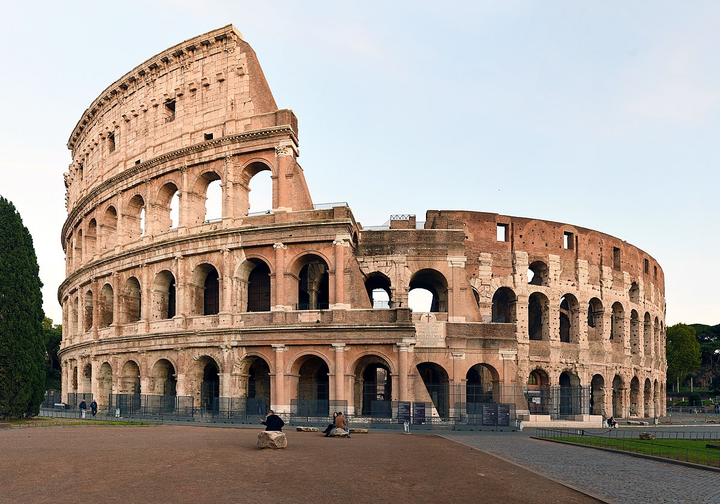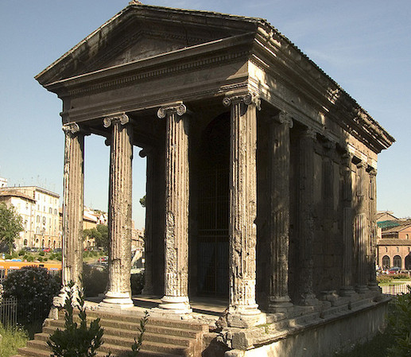 | Practise your times tables daily - can you challenge someone at home to see who can get the best score.   | Choose an object that would tell people from the future all about you if it was found by archaeologists. Draw it and label it to explain why it is an important artefact just like the ones we look at in our history lessons.  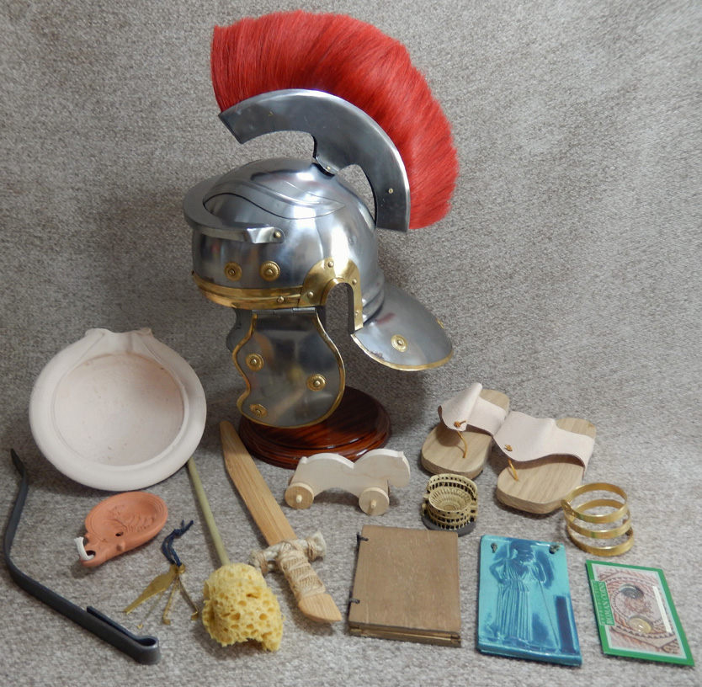
Design and make a Roman soldiers shield - you may have to do some research to see what they were like! | Write at least 5 questions that you would like to ask a Roman.  Challenge: can you find the answers??
Draw a Roman soldier and include all the things he would have.  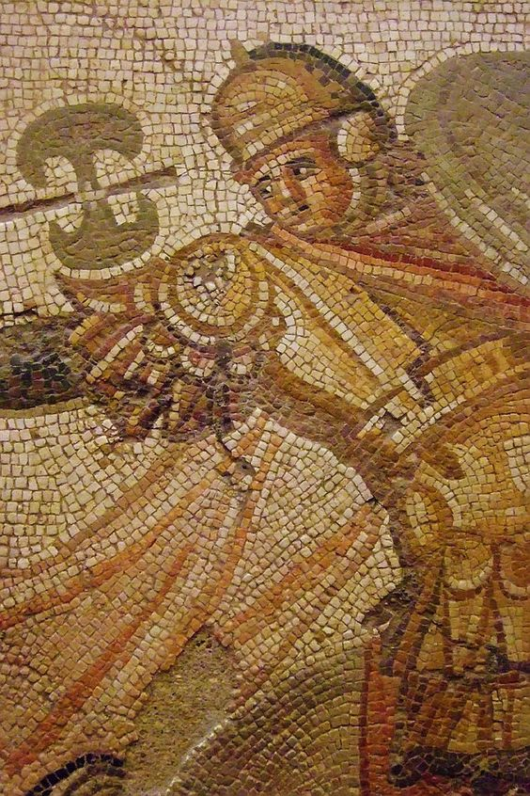  Can you make it look like a mosaic? | Create a quiz about the digestive system. You could include questions and images.   | Research one of the Roman emperors and share what you have found out in a poster or report.  