Week 1  Contractions  for 18.04.24 | Week 1  Revision y3-4  for 25.04.24 | Week 2  Revision y3-4  for 02.05.24 | Week 3  Revision y3-4  for 09.05.24 | Week 4  Revision y3-4  for 16.05.24 | Week 5  Revision y3-4  for 23.05.24
I’ve | dislike | answer | carefully | nature | know
we’d | disagreed | island | suddenly | creature | write
they’ve | invisible | February | finally | adventure | right
you’d | incomplete | length | completely | sensation | where
don’t | incorrect | strength | gently | explanation | wear
can’t | disappear | business | simply | information | weight
won’t | disappoint | dangerous | horribly | observation | wait
shouldn’t | impossible | nervous | women | through | week
couldn’t | impolite | poisonous | woman | thought | weak
haven’t | impatient | mountainous | various | though | therefore
In bold are the year 3 and 4 spellings for you to learn.
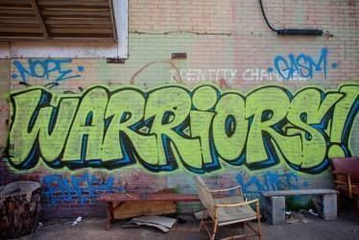
You could:
- Stick them on your fridge
- write out your spellings using different colours for each ‘chunk’ e.g. pl ay ing
- use a silly / posh / deep / squeaky voice when spelling out each word
- write a sentence with your spelling word in
- be the teacher! Teach someone at home how to spell the words!
Please ask if you need any help and have fun learning your spellings at home.

