Year 4 Home Learning
Learning Log tasks – Lindisfarne Gospels
Choose one task to complete each week.
Record your learning in your homework learning log book. We will share your learning every Friday so be prepared to talk about what you have done!
Have fun!
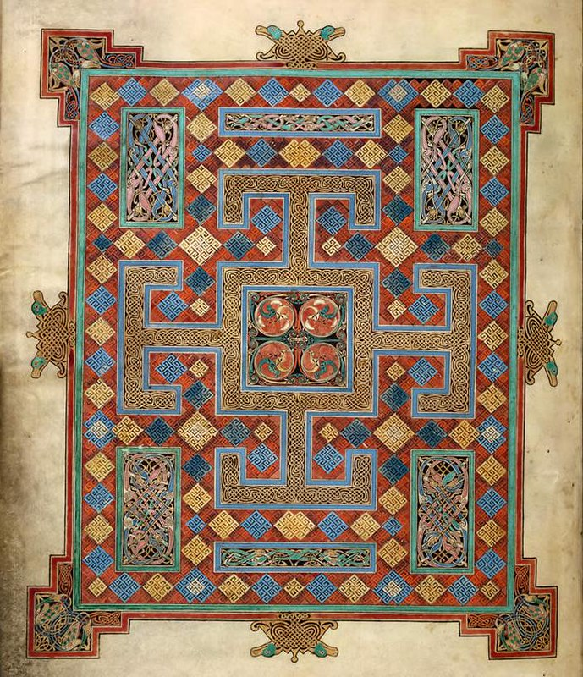  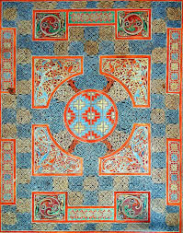  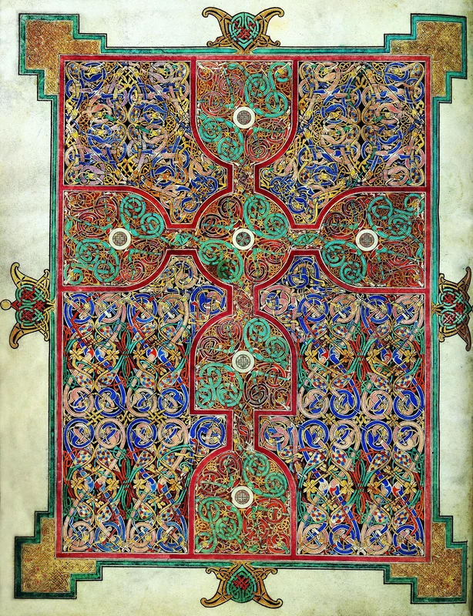  Create your own Gospels carpet page. Include patterns and colours similar to the images you have seen. |  | Draw your initial in the style of the illuminated letters. Use colour to make it stand out.
Go for a walk around where you live and record all the different sounds you can hear. Where is it the loudest/quietest? Use pictures and labels to create a map of what you hear.
Can you find any insects in your outside spaces at home? Have a go at sketching them. If you are able to get up close and observe, use this to help you add detail to your sketches. Draw your favourite insects. | Write 5 questions you would like to ask the monks on Lindisfarne. What would you like to know? Do some research to answer them.
Draw and label your ideal pencil case and its contents in French. Give it a wonderfully French design with lots of colour.
Spellings will be on Thursday mornings.
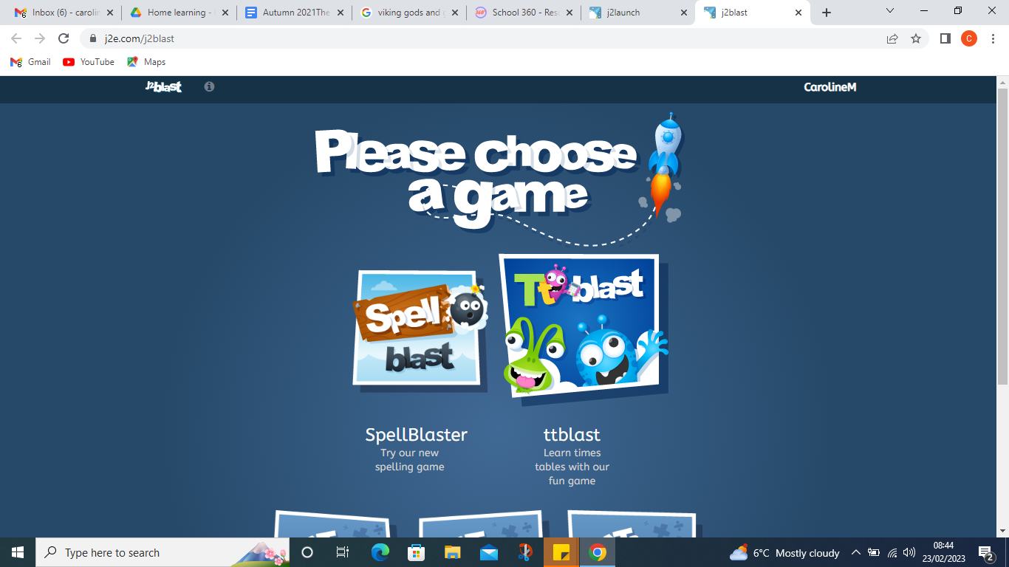
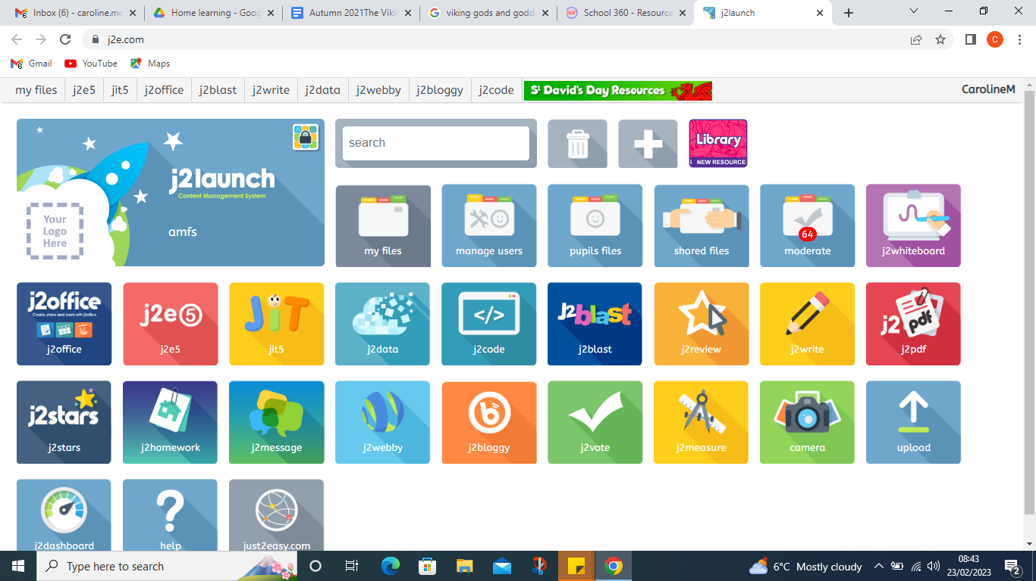
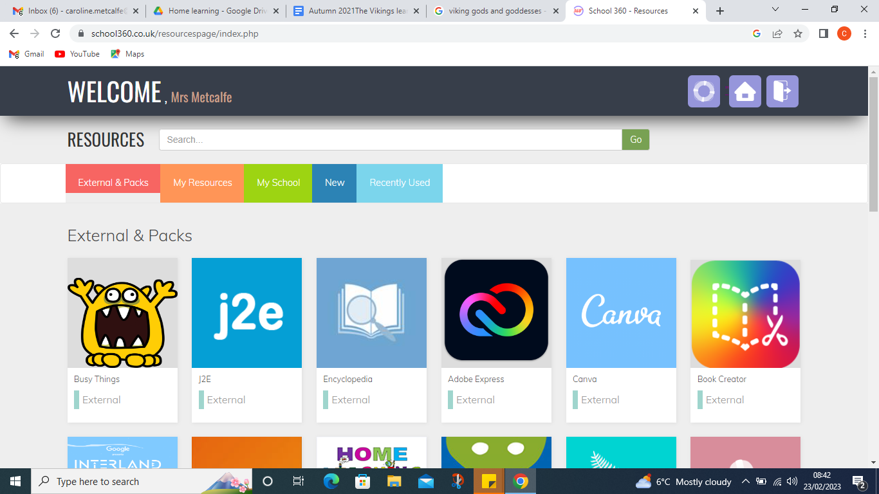
Keep up with your times table rockstars and if you would like to try something different you can access J2blast times tables on your school 360 resources page - go to resources, J2e, then choose the J2blast tile.

