Intent

At King Edwin Primary School, the teaching of Art and Design:

- Inspires children to experiment and create their own works of art, craft and design.
- Equips children with the knowledge and skills to appreciate different forms of art and design.
- Develops children’s ability to think critically and develop a more rigorous understanding of art.
- Enables children to understand how both art and design reflect and shape our history, and contribute to the culture, creativity and wealth of our nation.
- Educates children about great artists, craft makers and designers, and enables them to understand the historical and cultural development of their art forms.
- Allows children to appreciate and make use of the local area and environment when designing and creating artwork.

Implementation

Art and Design is taught each term focusing on the knowledge and skills laid out in the Nation Curriculum National Curriculum Art and Design. We provide full curriculum coverage for Art and Design, which develops children’s skills and knowledge across the following areas:
exploring and developing ideas, drawing, painting, sculpture, collage, textiles, printing, work of other artists. Children will revisit these areas, ensuring that they have the opportunity to practise and develop their skills.
At King Edwin Primary School we make links with the arts to all areas of the curriculum wherever possible. We celebrate our creations through displays, assemblies and sharing work with pupils and parents. We work with local artists to create a range of artwork from paintings to visual installations. Pupils are encouraged to express their ideas, knowledge and understanding in the creation of art and they use this inspiration to improve their skills. The local area is very important to us and we take the opportunity to share our artwork with the community through the Amble Puffin Festival and our use of the local beach to create large scale pieces.

Impact

It is our aim that children will retain knowledge and skills taught within each unit of work, remember these and understand how to use and apply these in their own art work, whilst beginning to understand what being an ‘artist’ means.

At King Edwin Primary School, we are able to measure the impact that Art and Design has had for all children by:

- Determining the extent to which objectives are met within each lesson and overall, at the end of each unit.
- Reviewing images of the children’s practical learning.
- Talking to the pupils about their learning (pupil voice).
- Holding moderation staff meetings where children’s books are discussed and there is the opportunity for a dialogue between teachers to understand their class’s work.
- Annual reporting of standards across the curriculum.

By the time children leave King Edwin Primary School, we want them to have developed a passion for art and creativity, working both independently and collaboratively. They will have grown in confidence when using a range of tools and techniques, becoming artists that can apply the skills and knowledge that they have developed throughout the years and respond critically to their own and other’s work.

Children at King Edwin Primary School have the opportunity to follow their progression of skills through their own sketchbooks which they use from Year 1 and throughout each year group, so their learning journey and skills progression is documented and can be reflected upon.

Art and Design Whole School Overview

Year Group | Autumn | Spring |  | Summer
In Early Years | Throughout the year children cover the key knowledge and understanding of the world statements through a range of topics. Children will:  Explore, use and refine a variety of artistic effects to express their ideas and feelings.  Return to and build on their previous learning, refining ideas and developing their ability to represent them  Watch and talk about dance and performance art, expressing their feelings and responses  Safely use and explore a variety of materials, tools and techniques, experimenting with colour, design, texture, form and function.  Share their creations, explaining the process they have used.  Use a range of small tools, including scissors, paintbrushes and cutlery.  Begin to show accuracy and care when drawing. |  | Children will cover these statements through a combination of adult led and child initiated activities throughout a range of topics over the year.  Children will have the opportunity to:  Explore a range of well known artists' most famous pieces of work (Van Gogh, Kandinsky, Pollack) and discuss what they like and dislike.  Create self portraits using pencil, paint and natural materials  Explore how colours change when they are mixed together  Use paint to create ‘night time’ effect pictures  Create their own dances to a range of pieces of music on PE sessions.
1 | Drawing – Animal markings  Children will be introduced to and use a variety of different drawing tools, focusing on line and pattern.  Children will learn about making varied and different marks on paper, explaining how they made them, with the use of tools, effectively manipulated for a desired effect. They will create illusion of texture with lines, dots and marks, creating a final outcome of a textured pattern drawing of animal skin.  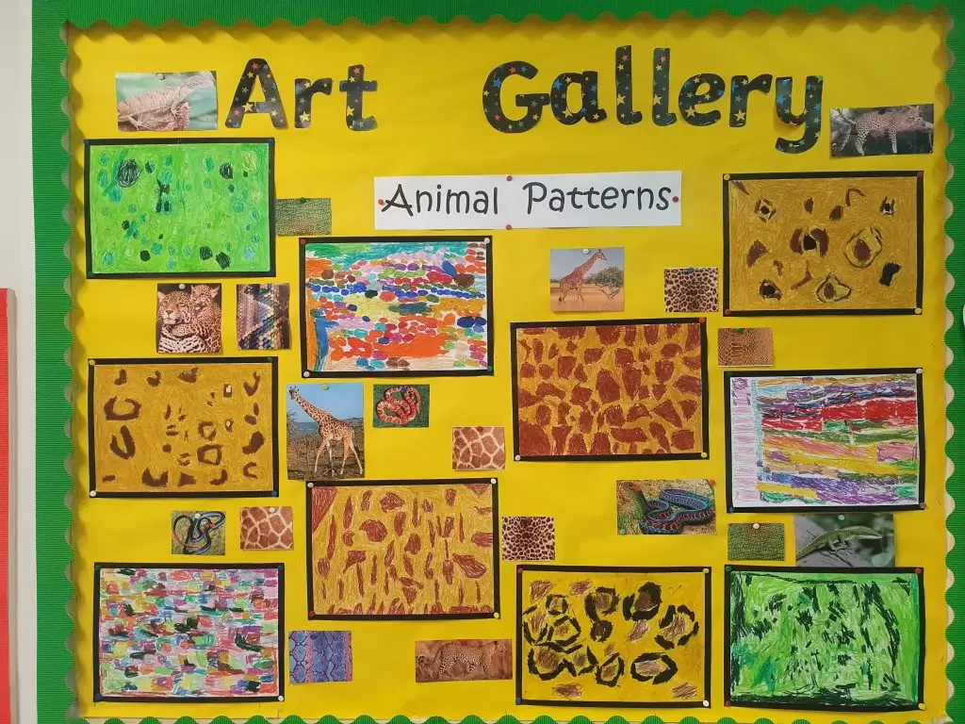  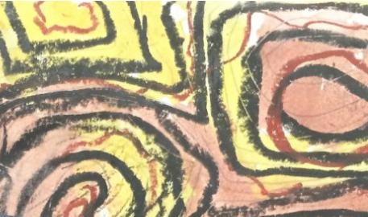  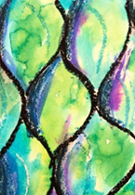  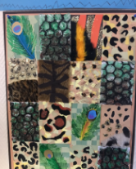 | Painting - Colour Chaos in animal prints.  Local Artist inspiration - Robert Oxley  Children will learn about choosing, using and mixing their own colours to create quality artwork. The children will have the opportunity to explore the life and work of six key abstract artists and, working primarily in paint, to create pieces in a range of abstract styles, as well as then apply their knowledge of mixing colours, to creating a variety of different textures to then apply to deepening their design of their animal print from the previous half term.  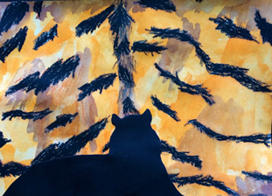  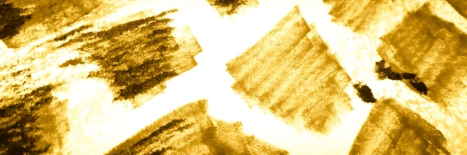  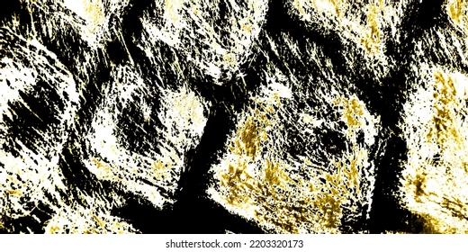  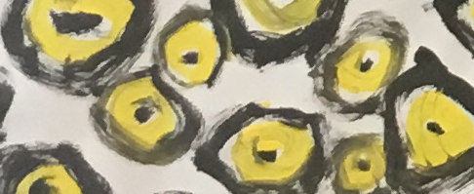  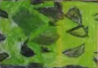  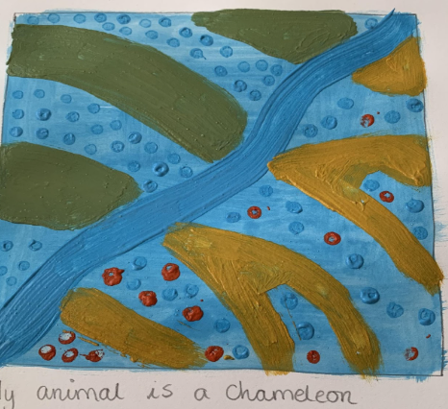 |  | Sculpting – Thumb pots animals (clay)  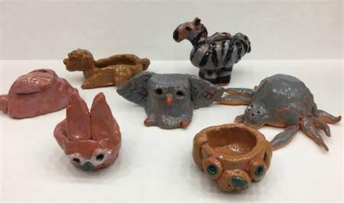  Children will explore how to use clay to create a simple pot with an animal theme. They will learn what clay is, how to safely and carefully shape it using their hands and basic tools, and how to join pieces together securely. Children will study different animals and think about how to show features like ears, tails, wings, or textures (like fur or scales) on their pots. They will develop their fine motor skills through pinching, rolling, smoothing, and joining clay. As artists, they will make creative choices about the shape and design of their pots and reflect on how well their sculpture represents their chosen animal. Children will also learn how to care for their work while it dries and understand that clay changes from soft to hard. Throughout the unit, they will build their confidence in experimenting with materials and talking about their ideas and finished pieces.  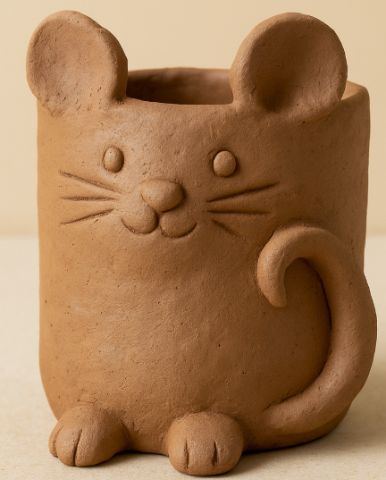
2 | Drawing – Austin’s butterfly inspired flowers.  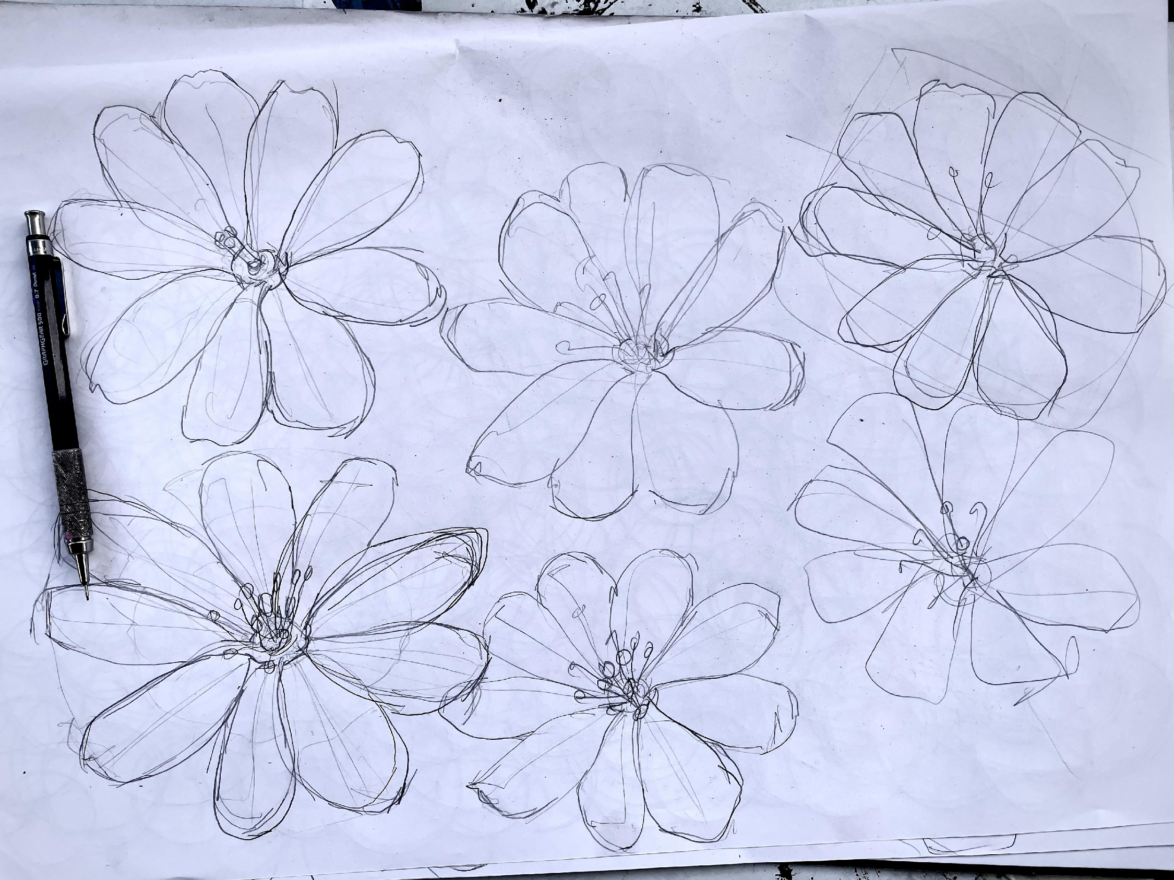  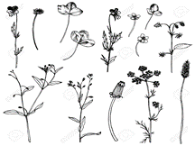  Children will begin to learn about sketching techniques. This unit is an introduction of scale and form accuracy. Children will learn to be reflecting and will ongoing evaluate realism then improve. They will be introduced to draft attempts. This unit is inspired by Austin’s butterfly. They will use one drawing tool to make different marks, using 2B and 4B pencils as they will also be introduced to smudging to add tone and texture.  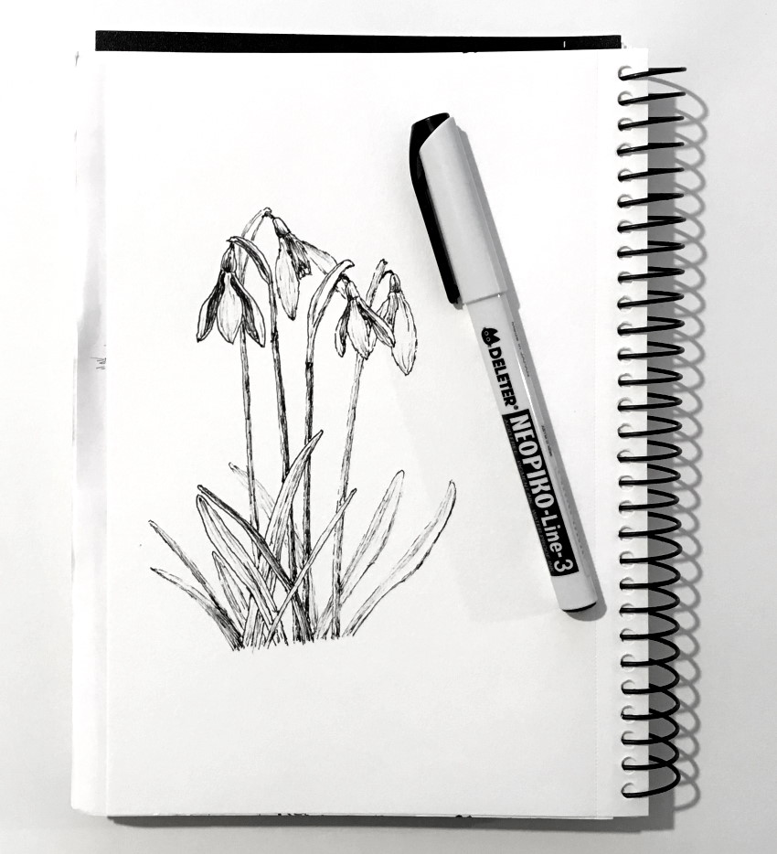  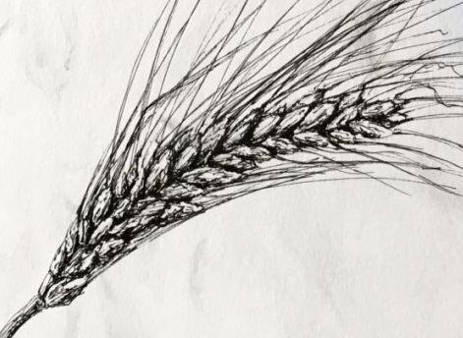 | Painting – Flowers, inspired by Van Gogh.  Local artist inspiration – Kerry Louise Bennett  Children will be taught how to create light and dark shades, how to paint WITHOUT ‘filling in’ a painted outline (very faint pencil outline will help) and then apply the different tones (tints or shades) to a painting. They will explore a variety of brush strokes such as thick and thin brushes, create patterns and then at the end of the unit children will then pull all their skills together to create a final product before evaluating their piece. Progress will be seen on lesson by lesson basis as children practice and refine each skill.  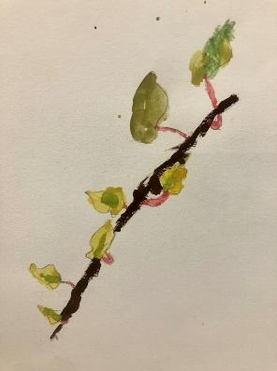  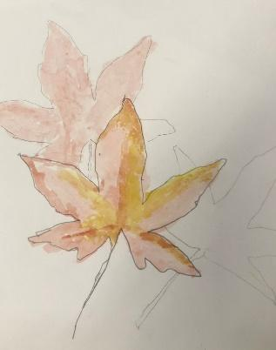  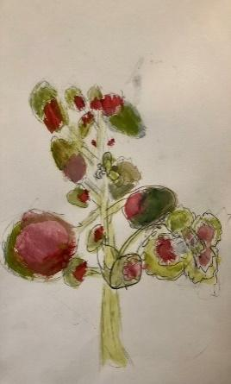 |  | Sculpting – Coil pots (clay)  Children will create a decorative, painted coiled pot, using full circumference coils blended on the inside (accentuating the coils on the outside, for decorative effect) and more create vertical coils to add individuality and demonstrate skill.  Children will secure manipulation techniques. Coiling as a joining and decorative technique  Use of smoothing as a joining/finishing technique Creative application of paint to clay.  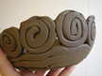  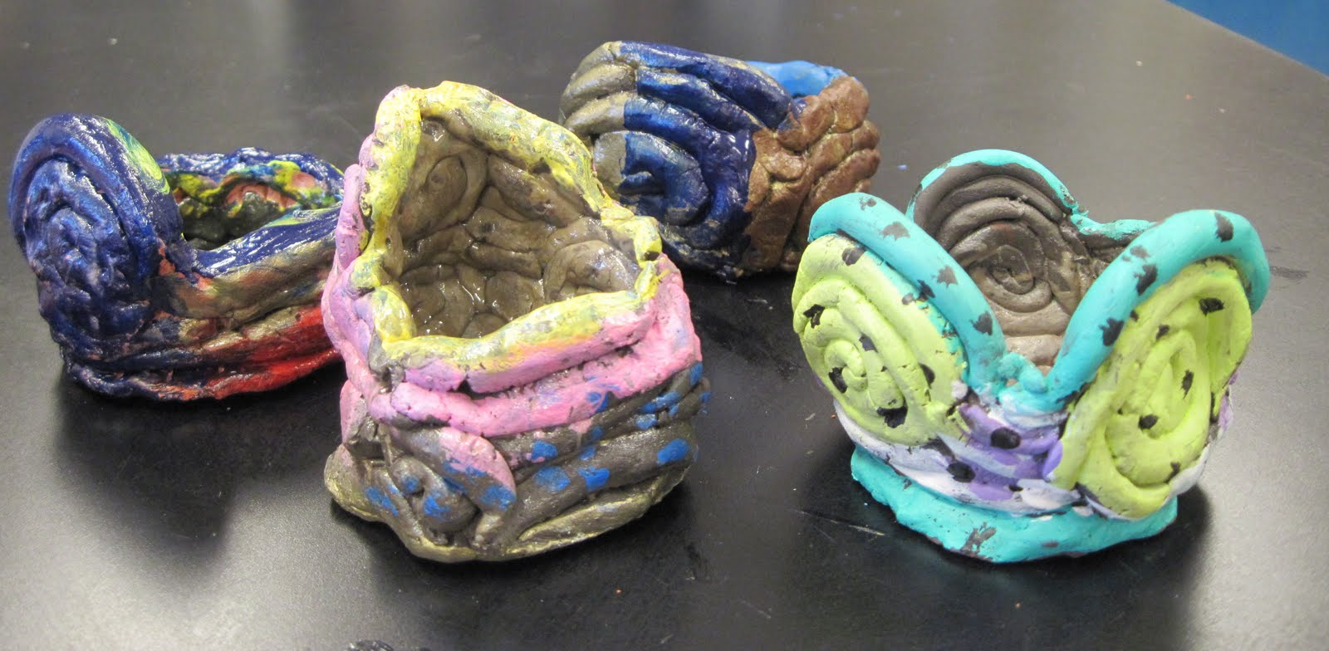  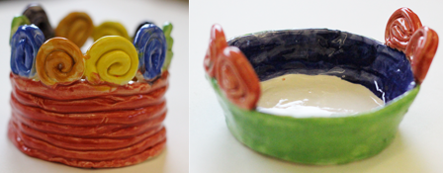  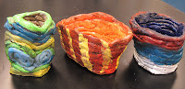
3 | Drawing – still life (Paul Cezanne)  Individual, well executed pencil drawings (a montage) of natural and manmade objects, with varied shading techniques suited to each. Children will know about different shading techniques and how to make different marks on paper to show light and shade..  Children will continue, and reinforce their understanding of form and how to draw it accurately. Children will reinforce their basic knowledge of scale and how it affects the accuracy of a realistic drawing. They will have applied it to real-life objects. Children will know how use of various types of shading, and pencil grip, and a variety of pencil angles can portray light and dark. Children will know about a using less, or no pencil marks to portray light.  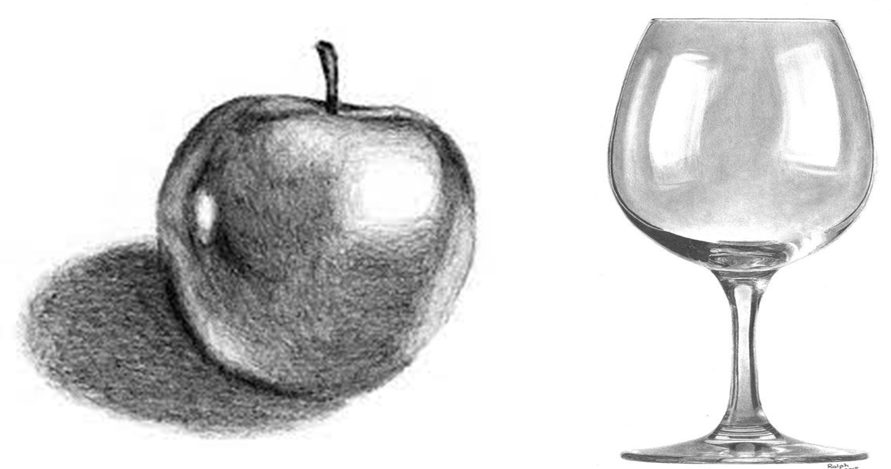  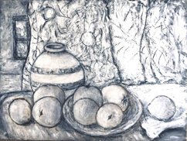 | Painting - Street art (Banksy/Jackson Pollock)  Children will design and create an A2 painting with street tag design.  A background of painting in the style of Jackson Pollock, using bold, vibrant flicked, poured and sponged colours with a personalised 3D ‘tag’ design, placed centrally.  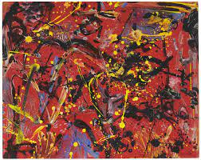  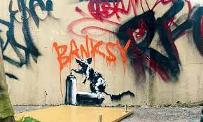 |  | Sculpting – wired mini beasts.  Local artist inspiration – Anna Turnbull from Biteabout Arts (willow sculptures)  Children will create an individual 3D wire sculpture of a chosen mini beast (max 30cm x 15cm) with a body covering of creative coloured materials (fabric, tissue paper, pipe-cleaners, recycled paper woven into the wire)  They will analyse insect and mini beast body shapes. Planning shape and colour and choices of creative embellishment of sculpture.  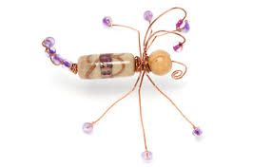  Making the creature’s shape using learnt wire-manipulation techniques.  Decorating creatively.  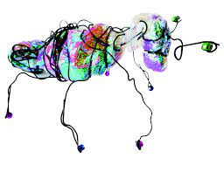  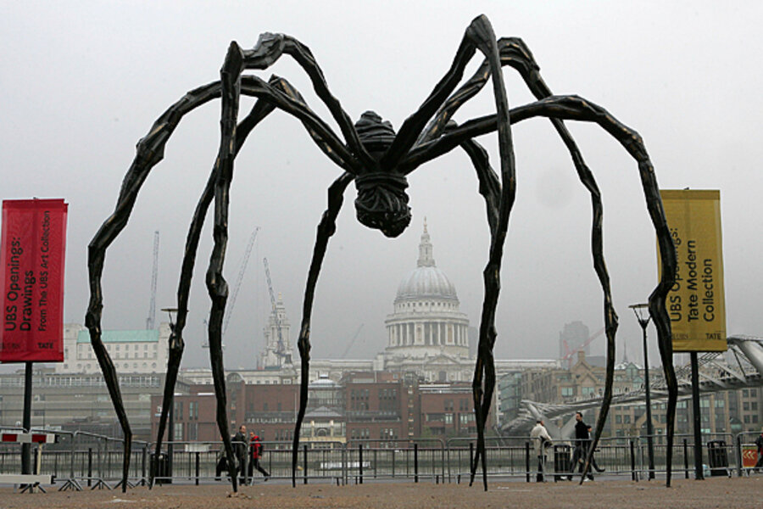  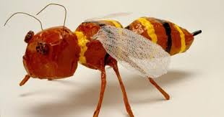  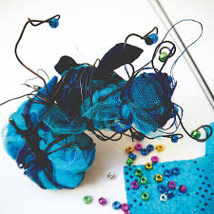
4 | Drawing – still life objects (Rembrandt)  Local artist inspiration – Fiona Carvell- still life.  Children will use drawing tools in a variety of more expressive, experimental and abstract ways. They will analyse different drawing styles and evaluate the emotion response they promote. Children will be able to link drawing styles with the emotional impact of a piece  And experiment with objects to create a pleasing composition.  They will create a composition drawing, with 3 or more items, carefully position and drawn as one piece. Drawing will show perspective and scale presented by objects being in front of one another.  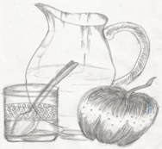  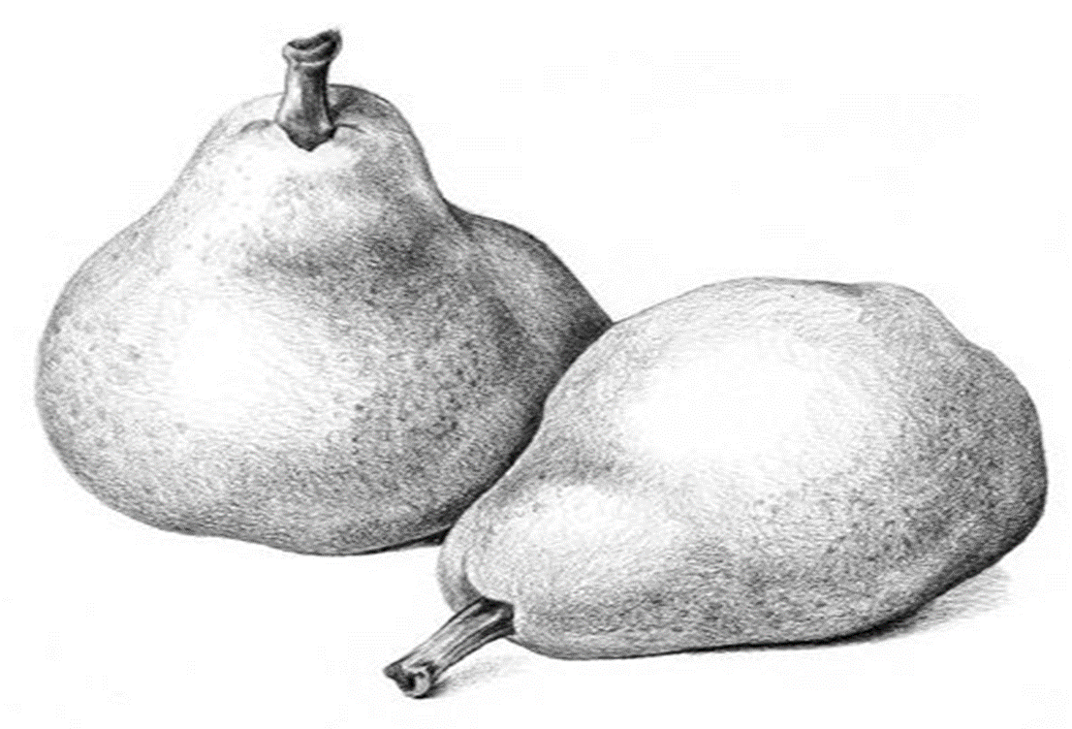 | Painting – Mood squares (Kandinsky)  Children will analyse various abstract art work by Wassily Kandinsky.  Analyse geometric shape and colour clashes/combinations.  Develop their ability to colour-mix effectively.  Children will experiment with composition to create a composite painting, consisting of 6x 10cm squares, done separately then arranged on an A4 sheet. Each is one a variation on a single shape, painted in either tints and shades of one colour, or various colours.  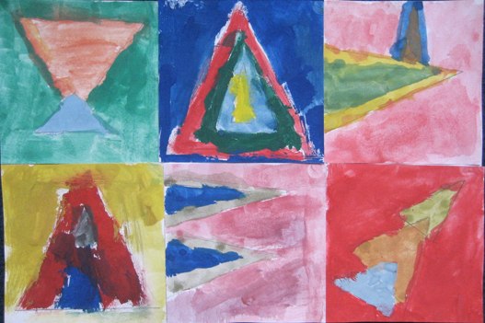  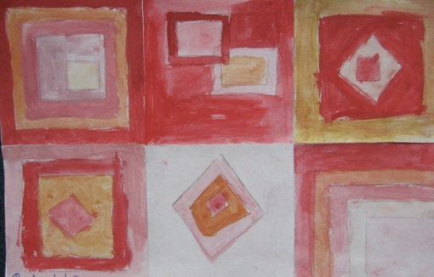  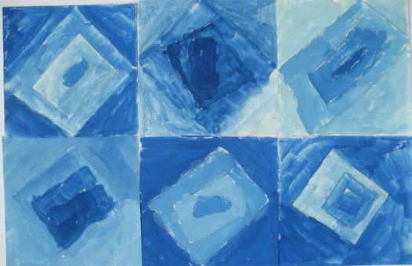  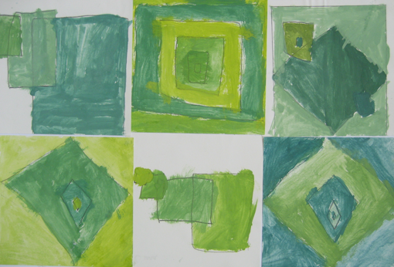 |  | Sculpting – emotion face tiles (clay)  Children will revise clay manipulation, use of clay-station and how to create robust, delicate shapes. They will practice ‘Score, Slip and Smooth’ to join two pieces of clay. Children will revise abstract portraiture, then designing and planning a final piece.  Creation and painting of final piece.  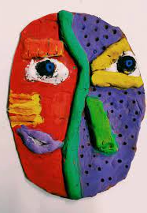  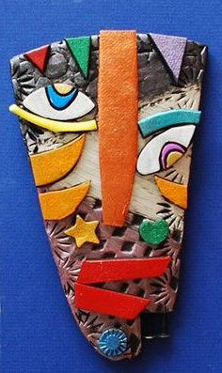  Children will create an abstract, painted ‘relief’ clay face in the style of Picasso, painted in appropriately contrasting colours to highlight features.  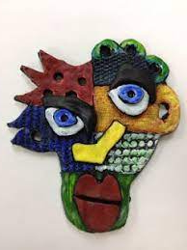  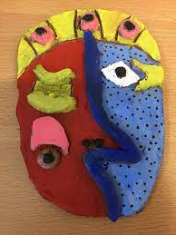
5 | Drawing - Portraits  Children will revise observational drawing  Carry out analysis of the rules of portraiture and how they link with number.  Evaluation of ‘before and after’ comparison pencil portraits.  Carry out an in-depth analysis and practice of drawing, and shading, specific facial features  Apply skills to a final, life-size portrait.  Children will produce an A3, to-scale, head and shoulders pencil portrait reflecting accurate portrait perspective.  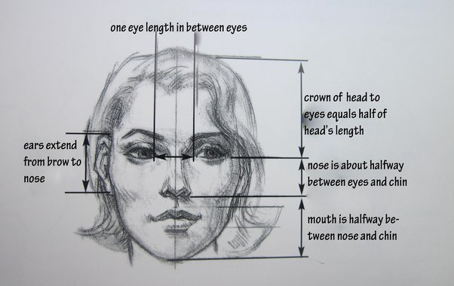  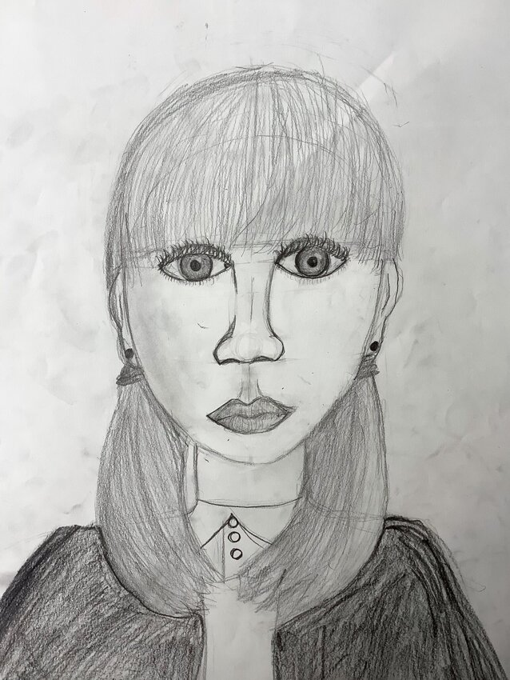 | Painting - pointillism portraits  Children will revise mixing tints and shades, introducing more subtle tones, using one primary colour, black and white. They will be introduced to, analyse and apply Pointillism, with light and shade being created by the density of painted dots. They will use the skill of colour-washing to create a base tone for the portrait. The children will create a final piece of a life size portrait painting (on A3 cartridge paper) where the rules of portrait drawing have been applied and only one primary colour has been used to create light and shade through tints, shades, tones, or pointillism.  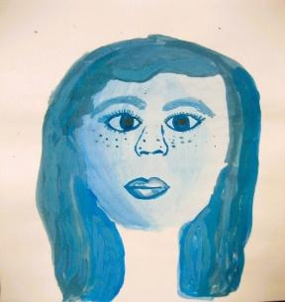  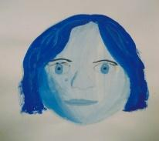  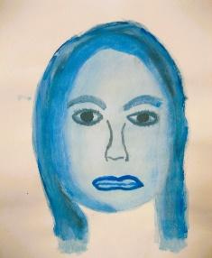 |  | Sculpting – Wired, dyed flowers  Local artist inspiration- Mary Ann Rodgers  Children will learn how to use pencil, watercolour, Hapa Zome printing, sculpture and paper modelling to create quality art work that shows progression in their skills. The children will also have the opportunity to explore the work of India Flint, Alexander Calder, David Oliveira, Henri Rousseau and local artist Mary Ann Rodgers. For a final piece, children will tie dye their own fabric which they will use to attach to wire to sculpt their 3D  flower.  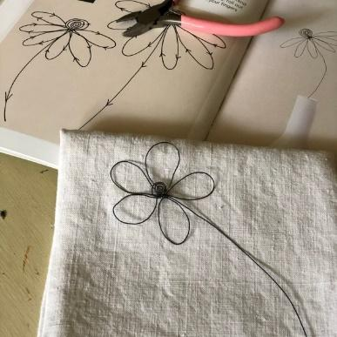
6 | Drawing – Perspective seaside (Local)  Local Artist inspiration – David Holliday .Children will look at composition and perspective. They will develop their understanding of the rules of perspective, diagonals and ‘vanishing points’. They will plan an effective composition from various visual sources and then manipulate different drawing and shading techniques to produce a desired effect. Children will create a final outcome of a pencil drawing with accurate perspective, based on subject matter/imagery from conflict.  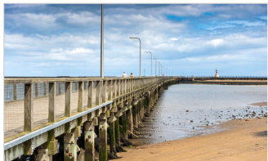  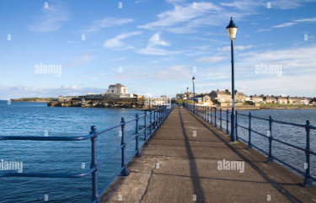  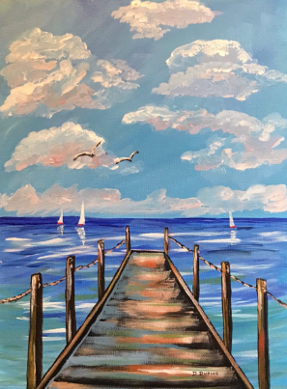 | Painting – WW2 artefact with texture (Impasto)  Children will effectively use tools to create texture. They will develop their knowledge and use of colour perspective as well as adding to a painting to create a wear and tear impression.  Children will produce an A4 painting (previously drawn using blocks of rich colour, which enhances the illusion of 3D by colour shades, tint and tone.  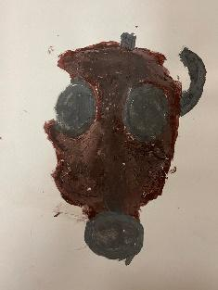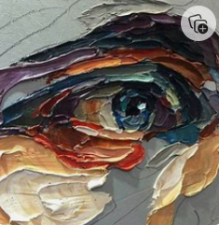 |  | Sculpting – Modroc human form. Henry Moore  Children will explore the composition of shapes developed from initial ideas to form a plan for a sculpture. They will talk about artists’ work and explain what they might use in their own work.  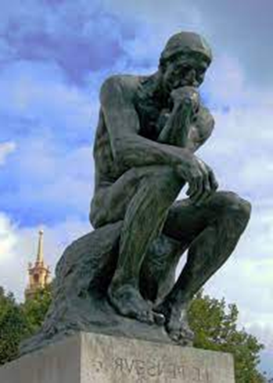  They will gather their ideas and produce a clear idea for a sculpture, including written notes and drawings to show their methods and materials needed (foil and Modroc). They will work towards successfully translating their plans to create a 3D sculpture.  