Year 4 Home Learning
Learning Log tasks – Smashing Saxons
Choose one task to complete each week.
Record your learning in your homework learning log book. We will share your learning every Friday in class beginning Friday 13th January so be prepared to talk about what you have done!
Keep practicing your times tables at home to see how far you can move up the charts and become a rock legend! | Data collection:  As a class we are going to collect data about our favourite food. Ask your family what their favourite food is and we will put the data together to create charts and graphs as part of our computing. | To keep ourselves healthy and fit while the nights are dark can you come up with a new sporting game. If we have time we can have a go at playing some of them.
Imagine that you have gone back to Anglo Saxon times. What questions might you like to ask the people you meet. Can you do some research to see if you can answer any. | 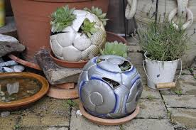  Reusing items that we don’t need anymore is a good way of helping the environment. Can you think of a way to upcycle an item from home? This could be an item of clothing or container that is no longer needed. Label a drawing of your idea or have a go at making it.
Create your own design for a new outfit. This could be something you would like to wear or it could be the next big thing in the shops. What will you make it out of? | Research Sutton Ho and create either a report or poster to include facts and drawings explaining what it is about. | Create a quiz about materials and their properties. This could include things that you have learned from previous years or new things we have learned.
Spelling test will be on Friday. Please practice the spellings listed for that week.

