Year 4 Home Learning
Learning Log tasks – Our Nordic Neighbours
Choose one task to complete each week.
Record your learning in your homework learning log book. We will share your learning every Friday in class beginning Friday 11th November so be prepared to talk about what you have done!
Research a recipe from Scandinavia and make it! You can add photos or explain how you made it. | Which countries are in Scandinavia?  Find out at least 3 facts about one and include a drawing of its flag. | To keep ourselves healthy and fit during the colder months can you research some exercises that you can do at home and create your own keep fit routine.
Imagine that you are on holiday in  Scandinavia. Write a postcard home.  Where are you?  What is it like? Why should I visit? | Research animals  that you’d find in  Scandinavia. Choose your favourite one and create a fact file about it. Could you keep it as a pet? | Hans Christian  Andersen was a  famous Danish  author. Which stories did he write? How many of them can you read?
Create your own  piece of artwork  (drawing/ model/  sculpture) inspired by John Bauer.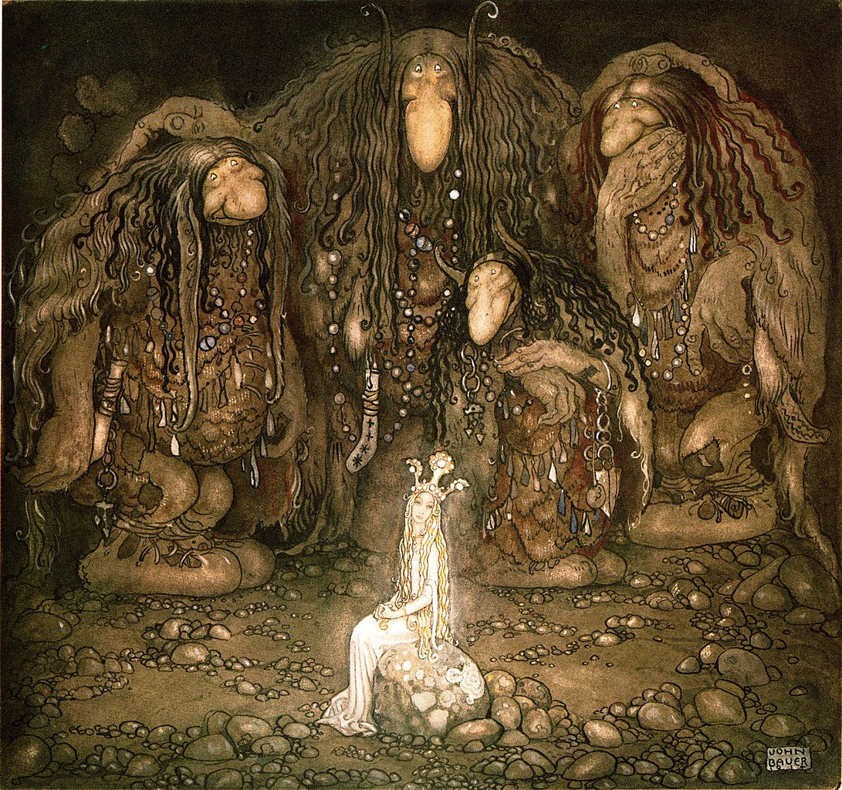 | Research the Sami people. What is their connection to Frozen 2? | What living things live around your home. Take a walk and see what living things (animals, plants, bugs) you can find. Make a list or take some photos to share.

