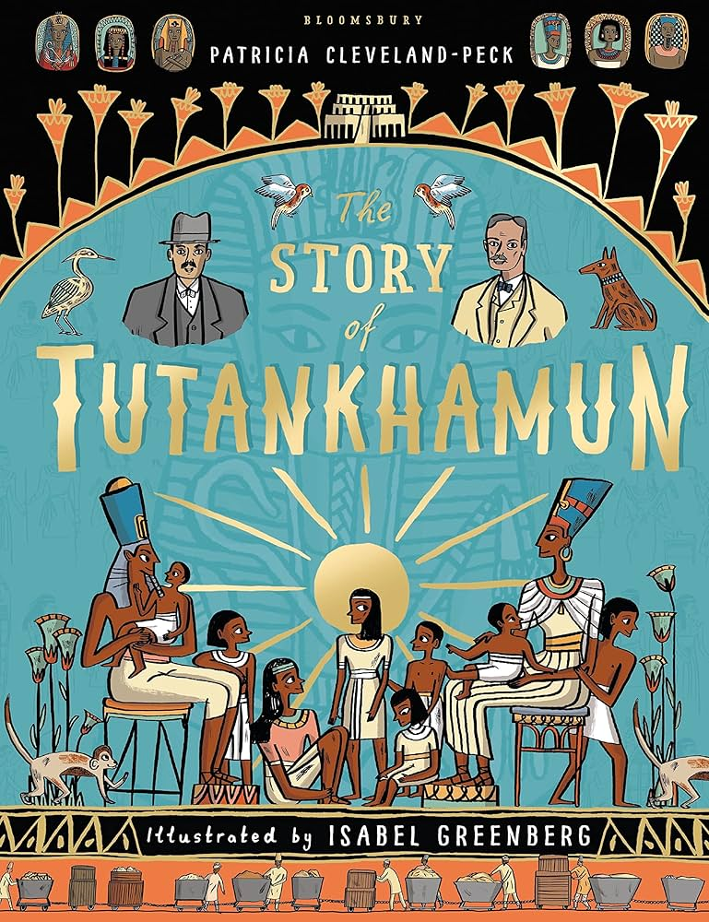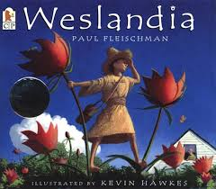

Our spellings this half term are based on ‘Weslandia’’ by Paul Fleischman and ‘The Story of Tutankhamun'by Patricia Cleveland-Peck, which we will be reading in our English lessons. Spellings will be tested on a Thursday.

|  |  |  |  |  |  |
| --- | --- | --- | --- | --- | --- |
| Week 3  learn for 18/09/25 | Week 4  learn for 24/09/25 | Week 5  learn for 01/10/25 | Week 6  learn for 08/10/25 | Week 7  learn for 15/10/25 | Week 8  learn for 22/10/25 |
| myths  Egypt  crypts  mystery  symbol  dynasty  mystical | centuries  history  reign  position  guide  learn  opposite | exercise  material  believe  different  interest  popular | joyous  mountainous  dangerous  numerous  fabulous | tremendous  hazardous  prosperous  mischievous  momentous | Words with the (ay) sound spelt ei, eigh, or ey  reign  feint  eight  eighth  weight  grey  prey |
|
|
|
|
|
|
|
|
|
|
|
|

You could:

* Stick them on your fridge
* write out your spellings using different colours for each ‘chunk’ e.g. pl ay ing
* use a silly / posh / deep / squeaky voice when spelling out each word
* write a sentence with your spelling word in
* be the teacher! Teach someone at home how to spell the words!