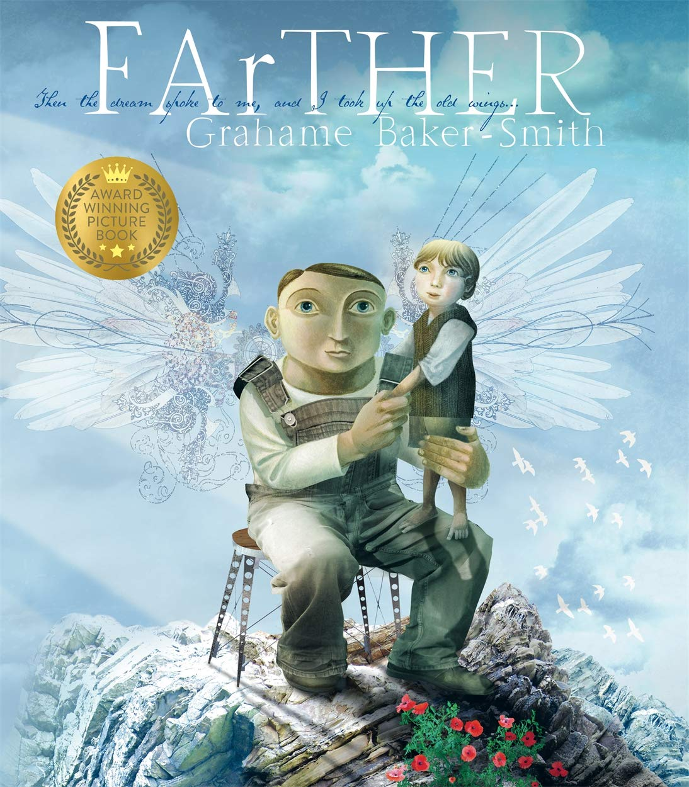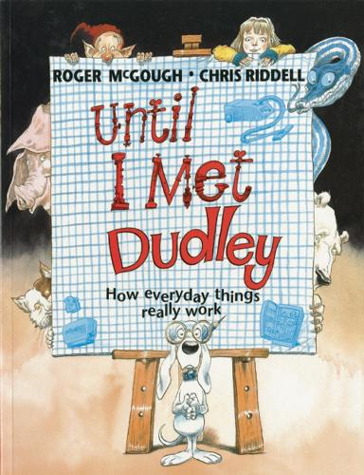

Our spellings this half term are based on ‘Father’ and ‘Until I met Dudley’, which we will be reading in our English lessons. Spellings will be tested on a Thursday.

|  |  |  |  |
| --- | --- | --- | --- |
| Week 1  learn for 01.05.25 | Week 2  learn for 08.05.25 | Week 3  learn for 15.05.25 | Week 4  learn for 22.05.25 |
| answer  bicycle  centre  guide  knowledge  learn  questions  suppose  therefore  minute | beginning  gardening  limited  preferred  opened  regretted  fastener  transmitter | complete  disappear  experiment  increase  learn  often  promise  regular  thought  different | invention  action  confession  electrician  expansion  expression  completion  musician |
|
|
|
|
|
|
|
|
|
|
|
|

You could:

* Stick them on your fridge
* write out your spellings using different colours for each ‘chunk’ e.g. pl ay ing
* use a silly / posh / deep / squeaky voice when spelling out each word
* write a sentence with your spelling word in
* be the teacher! Teach someone at home how to spell the words!